**Homework 1**

1. **Consider the platform model we studied in the lecture. Sellers are of two types, $c_{L}$ and $c_{H}$. Buyers are also of two types, $v_{L}$ and $v_{H}$. Each type consists of half of the population in each group. The modification in this exercise is that now every pair of match generates positive surplus, i.e., $v_{H}>v_{L}>c_{H}>c_{L}$. We still assume that there exists a decentralized market where agents randomly match and the surplus is evenly split between a buyer and a seller.**
2. **Write down all agents’ payoffs in the decentralized market if the platform is absent.**

Payoff of $v_{H}$ is ($v_{H}-c_{H}$)/8+($v_{H}-c_{L}$)/8

Payoff of $v_{L}$ is ($v_{L}-c_{H}$)/8+($v_{L}-c_{L}$)/8

Payoff of $c_{H}$ is ($v_{H}-c_{H}$)/8+($v_{L}-c_{H}$)/8

Payoff of $c_{L}$ is ($v_{H}-c_{L}$)/8+($v_{L}-c_{L}$)/8

1. **Write down the total welfare in the decentralized market if the platform is absent.**

If the platform is absent, the total welfare is =($v_{H}-c_{H}$)/4 $+$ ($v_{H}-c_{L}$)/4 $+$ ($v_{L}-c_{L}$)/4 $+$ ($v_{L}-c_{H}$)/4=($v_{H}{+v}_{L}-c_{H}-c_{L}$)/2

1. **Now we introduce a profit-maximizing platform who acts as a dealer between buyers and sellers. What prices can the platform charge to segment the market so that only the more efficient types join the platform.**

The platform should charge buyers at $p_{B}$ =($v_{H}+c_{H}$)/2 and charge sellers at $p_{s}$ =($v_{L}+c_{L}$)/2 for the following reasons.

First, to make $v_{H}$ remain in the platform, there should be $v_{H}-p_{B}≥\frac{v_{H}-c_{H}}{2}$.

To make $c_{L}$ remain in the platform, there should be $p_{C}-c_{L}≥\frac{v_{L}-c_{L}}{2}$.

To keep $v_{L}$ out of the platform, there should be $p_{B}> \frac{v_{L}+c_{H}}{2}$.

To keep $c_{H}$ out of the platform, there should be $p_{C}< \frac{v_{L}+c_{H}}{2}$.

In order to maximize the profit, we want $p_{B}$ to be as high as possible, and $p_{C}$ to be as low as possible. So we have $p_{B}$ =($v_{H}+c_{H}$)/2 and $p_{s}$ =($v_{L}+c_{L}$)/2.

1. **Verify that all types of agents have no incentive to deviate.**

${ p}_{B}$ =($v_{H}+c_{H}$)/2 and $p_{s}$ =($v_{L}+c_{L}$)/2

Actually, we have proved it in question c.

For $v_{H}$ and $c_{L}$, $v_{H}-{ p}_{B}$ =($v_{H}-c_{H}$)/2 and $p_{s}-c_{L}$ =($v_{L}-c_{L}$)/2, so those two efficient types have no incentive to deviate.

For $v_{L}$ and $c_{H}$, $p_{B}> \frac{v_{L}+c_{H}}{2}$ and $p_{C}< \frac{v_{L}+c_{H}}{2}$. , so those two not efficient types have no incentive to deviate.

1. **Does the platform make positive profit?**

Yes. ${ p}_{B}$ > $p_{s}$

1. **Who are better off and who are worse off after introducing the platform?**

They are all worse off after introducing the platform.

For $v_{H}$, they are worse off because the payoff decreases from ($v_{H}-c_{H}$)/8 $+$ ($v_{H}-c_{L}$)/8 to ($v_{H}-c_{H}$)/4, and the difference is ($c_{L}{-c}_{H}$)/8<0

For $v_{L}$, they are worse off because the payoff decreases from ($v_{L}-c_{H}$)/8 $+$ ($v_{L}-c_{L}$)/8 to ($v_{L}-c_{H}$)/4, the difference is($c_{L}{-c}_{H}$)/8<0

For $c_{L}$, they are worse off because the payoff decreases from ($v_{H}-c_{L}$)/8+($v_{L}-c_{L}$)/8 to ($v_{L}-c_{L}$)/4, the difference is($v_{L}{-v}_{H}$)/8<0

For $c_{H}$, they are worse off because the payoff decreases from ($v_{H}-c_{H}$)/8+($v_{L}-c_{H}$)/8 to ($v_{L}-c_{H}$)/4, the difference is($v_{L}{-v}_{H}$)/8<0

1. **Is the total welfare enhanced after introducing the platform? Explain why.**

No. If we take the welfare of the platform into account, then the welfare does not change. If we only consider the buyers and sellers, then the welfare decrease for the platform earns positive profit.

1. **Derive the demand curve with network effect.**

As we know consumer i’s utility is given by

$$U_{i}=\left\{\begin{aligned}w_{i}f-p, if he purchases the good \\ 0, otherwise \end{aligned}\right.$$

where $f$ denotes the expected proportion of consumers who will buy the good.

The demand by consumer $i$ for a fax machine is therefore given by:

$$q_{i}=\left\{\begin{aligned} 0, if w_{i}f<p \\ 1 , if w_{i}f≥p\end{aligned}\right.$$

In order to solve the demand curve, we want to find a Nash equilibria different from all 0’s equilibria. We find a marginal consumer, and denote his valuation by $\tilde{w}$. $\tilde{w}$ satisfies

$$\tilde{w}f-p=0$$

By definition of $\tilde{w}$:

* All consumers with $wi≥\tilde{w}$ will purchase in a Nash equilibrium.
* All consumers with $wi<\tilde{w}$ will not purchase in a Nash equilibrium.

Therefore, if $f$ and $\tilde{w}$ arise in a Nash equilibrium, it has to be that

$$100f=100-\tilde{w}$$

Combining the two above conditions, we can get rid of $\tilde{w}$, and conclude that $f$ can be sustained in a Nash equilibrium if and only if

$$p = 100f (1-f)$$

In other words, marginal individual’s valuation $\tilde{w}f=p = 100f (1-f)$.

Then we can draw the demand curve with network effect, the vertical axis is marginal consumer’s willing to pay, which is price, and the horizonal axis is the demand quantity (shown as a real number between 0 and 1).

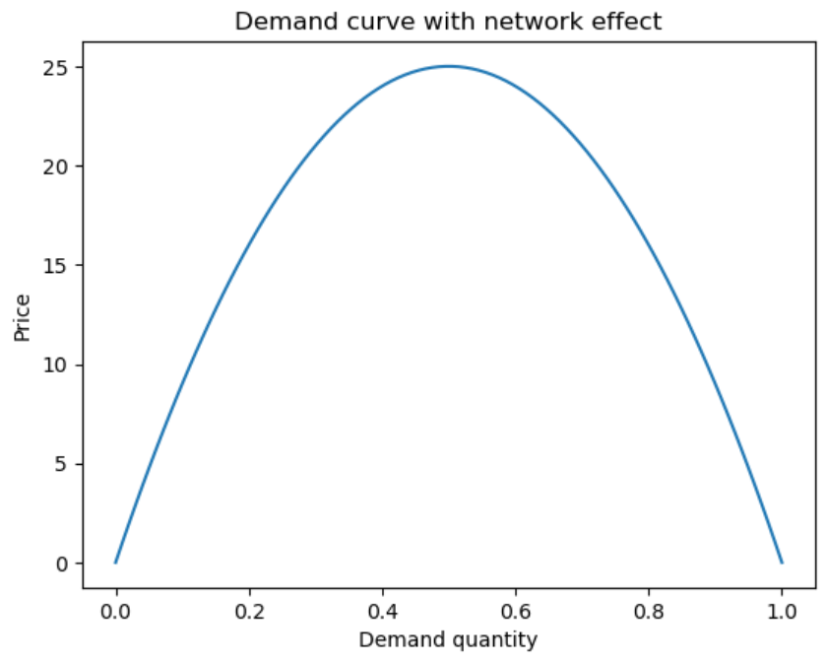

**3. Read the attached article about Ebay and address the following questions:**

**a) Comment on entrant’s idea that lowering or eliminating listing fees is a good way to attract more sellers.**

I think waiving listing fees of specific categories is efficient to stimulating selling. With lower listing fees, the balance point on the supply curve will move to left, and supply will be higher. However, lowering or eliminating too much listing fees will lower the profit of Ebay.

**b) Explain the nature of the network externalities in this market, both positive and negative.**

Positive:

1. With more buyers in the market, goods will be easier to sell. While with more sellers in the market, buyers are easier to find proper good.
2. With more buyers in the market, a buyer will be easier to know whether the good fits himself/herself by finding other buyers’ comments. The same is true for the sellers.

Negative:

1. More sellers -> Price competition -> Harder to sell for high prices -> Less sellers

2. More sellers of Brand factory -> Lower price since the technology and ingredients advantage of factory -> Less individual sellers

**c) In light of your answer to part b), comment on the strategy of entrants targeting specific categories of goods, as opposed to tackling Ebay head-on across all categories.**

The strategy will attract more sellers to Ebay on specific category, which will enhance buyers of that category for the positive network effect. However, if too many sellers are attracted to the market, the average quality will probably be lower and buyers are harder to distinguish. So a proper listing fee is important.